FELIN 2023

Forward & inverse kinematics and DYNAMIC

# BODY REFERENCE FRAME (BRF)

* Right-hand coordinate system
* Centred on body geometric centre,
* X forward
* Y leftward
* Z upward

In the default standing pose, the position of the feet in the body reference frame is defined by the following constants:

* Delta X (note: positive)
* Delta Y (note: positive)
* Shift X (note: a longitudinal displacement to centre the ground projection of the CoM between all feet)
* Default Z Reference (note: negative)

# Robot pose matrix

The pose of the robot is expressed using a 3x4 matrix.

Each column is the 3D coordinates of a foot.

The column order is:

$$\left|\begin{matrix}FR & FL & RR & RL\end{matrix}\right|$$

In the default standing pose, the content of the pose matrix, in the body reference frame, is:

$${DEFAULT_STANCE=\left|\begin{matrix}delta_{x}+shift_{x} & delta_{x}+shift_{x} & -delta_{x}+shift_{x} & -deltat_{x}+shift_{x} \\ -delta_{y} & delta_{y} & -delta_{y} & delta_{y} \\ default_{z_{ref}} & default_{z_{ref}} & default_{z_{ref}} & default_{z_{ref}}\end{matrix}\right|}_{BRF}$$

*Note: see Config.py in “default stance” member function.*

# LEG REFERENCE FRAME (LRF)

* Right-hand coordinate system
* Centred on hips revolute joints,
* X upward
* Y leftward
* Z backward

The leg reference frame is aligned with the first (abduction) hips revolute joint.

The origin of the legs is defined by the following constants:

* Leg Front-Back (note: positive)
* Leg Left-Right (note: positive)

The origin of a leg is **fixed** in the robot reference frame and located at the **intersection** of hips abduction and flexion/extension axis.

The 3D coordinates of the leg origins may be expressed by a 3x4 matrix. Each column is the 3D coordinates of a leg origin. The column order is the same as the robot pose matrix:

$$\left|\begin{matrix}FR & FL & RR & RL\end{matrix}\right|$$

In the body reference frame, the content of the leg origin matrix is:

$$LEG_ORIGIN={\left|\begin{matrix}LEG_FB & LEG_FB & -LEG_FB & -LEG_FB \\ -LEG_LR & LEG_LR & -LEG_LR & LEG_LR \\ 0 & 0 & 0 & 0\end{matrix}\right|}_{BRF}$$

*Note: see Config.py in “leg origin” matrix.*

For the FR leg, the transformation matrix from LRF to BRF is:

$$T_{LRF}^{BRF}=\left[\begin{matrix}0 & 0 & -1 & LEG_FB \\ 0 & 1 & 0 & -LEG_LR \\ 1 & 0 & 0 & 0 \\ 0 & 0 & 0 & 1\end{matrix}\right]$$

For the FR leg, the transformation matrix from BRF to LRF is:

$$T_{BRF}^{LRF}=\left[\begin{matrix}0 & 0 & 1 & 0 \\ 0 & 1 & 0 & LEG_LR \\ -1 & 0 & 0 & LEG_FB \\ 0 & 0 & 0 & 1\end{matrix}\right]$$

*Note: see Kinematics.py in “four legs inverse kinematics” function.*

# Forward kinematics using Modified Denavit-Hartenberg method (DHm)

## Modified DH Parameters

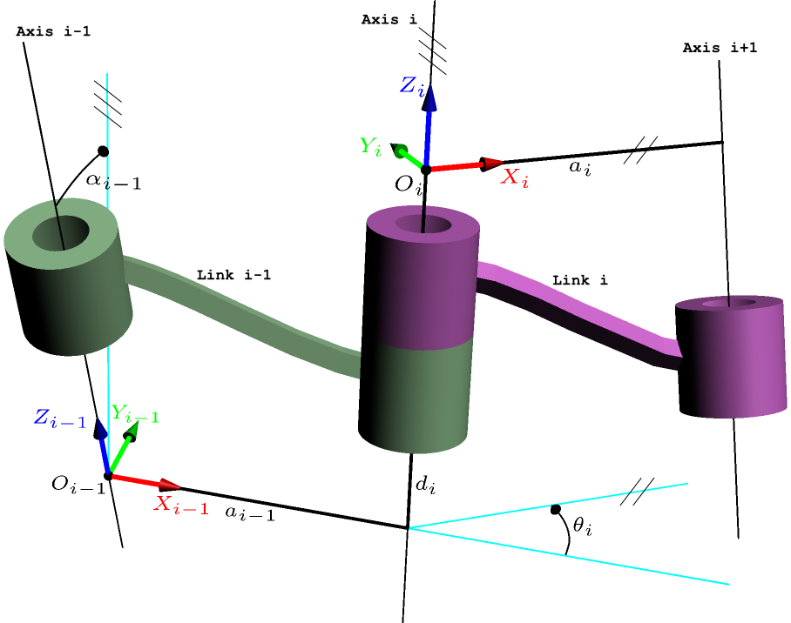

* $θ$ is rotation about Z axis of this joint,
* **d** is translation along Z axis of this joint,
* **a** is length of link attached to this joint,
* **α** is twist of the link attached to this joint.

|  |  |  |  |  |
| --- | --- | --- | --- | --- |
| Links | $$θ$$ | d | $$α$$ | a |
| 1 (hips/abduction) | $$θ_{1}$$ | 0 | -90° | 0 |
| 2 (hips flexion/extension) | $θ_{2}+90$ ° | $La$* | 0° | $$Lf$$ |
| 3 (knee) | $$θ_{3}-180°$$ | 0 | 0° | $$Lt$$ |

Note (*): + for left legs | - for right legs.

where

|  |  |  |
| --- | --- | --- |
| Variables | Description | Values |
| $$La$$ | Abduction offset | 60 mm |
| $$Lf$$ | Length of femur | 140 mm |
| $$Lt$$ | Length of tibia to centre of foot (foot radius = 10mm) | 150 mm |
| $$θ_{1}$$ | Hips (abduction) revolute joint angle, ZERO when VERTICAL | *controlled by servo #1* |
| $$θ_{2}$$ | Hips (flexion/extension) revolute joint angle, 180° when femur is HOR | *controlled by servo #2* |
| $$θ_{3}$$ | Knee revolute joint angle, 90° when TIBIA is VERTICAL | *controlled by servo #3* |

## Transformation matrices using modified DH parameters

### (reminder) modified DH transformation matrix

Transformation from coordinate frame j to coordinate frame j-1:

$$T_{j}^{j-1}\left(θ_{j}d_{j}a_{j-1}α_{j-1}\right)=\left[\begin{matrix}\cos{θ_{j}} & -\sin{θ_{j}} & 0 & a_{j-1} \\ \sin{θ_{j}}\cos{α_{j-1}} & \cos{θ_{j}}\cos{α_{j-1}} & -\sin{α_{j-1}} & -d_{j}\sin{α_{j-1}} \\ \sin{θ_{j}}\sin{α_{j-1}} & \cos{θ_{j}}\sin{α_{j-1}} & \cos{α_{j-1}} & d_{j}\cos{α_{j-1}} \\ 0 & 0 & 0 & 1\end{matrix}\right]$$

### HIPS (Abduction) (j=1)

$$T_{1}^{0}=\left[\begin{matrix}c_{1} & -s_{1} & 0 & 0 \\ s_{1} & c_{1} & 0 & 0 \\ 0 & 0 & 1 & 0 \\ 0 & 0 & 0 & 1\end{matrix}\right]$$

where

|  |  |
| --- | --- |
| $$c_{1}$$ | $$\cos{θ_{1}}$$ |
| $$s_{1}$$ | $$\sin{θ_{1}}$$ |

### HIPS (FLEXION/EXTENSION) (j=2)

* For left legs:
$$T_{2}^{1}=\left[\begin{matrix}c_{2} & -s_{2} & 0 & 0 \\ 0 & 0 & 1 & L_{a} \\ -s_{2} & -c_{2} & 0 & 0 \\ 0 & 0 & 0 & 1\end{matrix}\right]$$

* For right legs:

$$T_{2}^{1}=\left[\begin{matrix}c_{2} & -s_{2} & 0 & 0 \\ 0 & 0 & 1 & -L_{a} \\ -s_{2} & -c_{2} & 0 & 0 \\ 0 & 0 & 0 & 1\end{matrix}\right]$$

where

|  |  |
| --- | --- |
| $$c_{2}$$ | $$\cos{θ_{2}+90}$$ |
| $$s_{2}$$ | $$\sin{θ_{2}+90}$$ |

### KNEE (j=3)

$$T_{3}^{2}=\left[\begin{matrix}c_{3} & -s_{3} & 0 & L_{f} \\ s_{3} & c_{3} & 0 & 0 \\ 0 & 0 & 1 & 0 \\ 0 & 0 & 0 & 1\end{matrix}\right]$$

where

|  |  |
| --- | --- |
| $$c_{3}$$ | $$\cos{θ_{3}-180°}$$ |
| $$s_{3}$$ | $$\sin{θ_{3}-180°}$$ |

### FOOT (j=4)

$$T_{4}^{3}=\left[\begin{matrix}1 & 0 & 0 & L_{t} \\ 0 & 1 & 0 & 0 \\ 0 & 0 & 1 & 0 \\ 0 & 0 & 0 & 1\end{matrix}\right]$$

### « end-effector » Transformation matrix to leg reference frame

* For left legs:
$$T_{4}^{0}=T_{1}^{0}T_{2}^{1}T_{3}^{2}T_{4}^{3}=\left[\begin{matrix}c_{1}c_{23} & -c_{1}s_{23} & 0 & c_{1}c_{23}L_{t}+c_{1}c_{2}L_{f}-s_{1}L_{a} \\ s_{1}c_{23} & -s_{1}s_{23} & 0 & s_{1}c_{23}L_{t}+s_{1}c_{2}L_{f}+c_{1}L_{a} \\ -s_{23} & -c_{23} & 1 & -s_{23}L_{t}-s_{2}L_{f} \\ 0 & 0 & 0 & 1\end{matrix}\right]$$

* For right legs:

$$T_{4}^{0}=T_{1}^{0}T_{2}^{1}T_{3}^{2}T_{4}^{3}=\left[\begin{matrix}c_{1}c_{23} & -c_{1}s_{23} & 0 & c_{1}c_{23}L_{t}+c_{1}c_{2}L_{f}+s_{1}L_{a} \\ s_{1}c_{23} & -s_{1}s_{23} & 0 & s_{1}c_{23}L_{t}+s_{1}c_{2}L_{f}-c_{1}L_{a} \\ -s_{23} & -c_{23} & 1 & -s_{23}L_{t}-s_{2}L_{f} \\ 0 & 0 & 0 & 1\end{matrix}\right]$$

where

|  |  |
| --- | --- |
| $$c_{23}$$ | $$\cos{θ_{2}+θ_{3}-90°}$$ |
| $$s_{23}$$ | $$\sin{θ_{2}+θ_{3}-90°}$$ |

## Forward Kinematic

Position of foot in leg reference frame is given by the 3x1 submatrix of $T_{3}^{0}$ describing translation:

* For left legs:
$$P_{θ_{c},θ_{h},θ_{k}}^{0}=\left[\begin{matrix}c_{1}c_{23}L_{t}+c_{1}c_{2}L_{f}-s_{1}L_{a} \\ s_{1}c_{23}L_{t}+s_{1}c_{2}L_{f}+c_{1}L_{a} \\ -s_{23}L_{t}-s_{2}L_{f}\end{matrix}\right]$$

* For right legs:

$$P_{θ_{c},θ_{h},θ_{k}}^{0}=\left[\begin{matrix}c_{1}c_{23}L_{t}+c_{1}c_{2}L_{f}+s_{1}L_{a} \\ s_{1}c_{23}L_{t}+s_{1}c_{2}L_{f}-c_{1}L_{a} \\ -s_{23}L_{t}-s_{2}L_{f}\end{matrix}\right]$$

Where

|  |  |
| --- | --- |
| $$c_{1}$$ | $$\cos{θ_{1}}$$ |
| $$s_{1}$$ | $$\sin{θ_{1}}$$ |
| $$c_{2}$$ | $$\cos{θ_{2}+90}$$ |
| $$s_{2}$$ | $$\sin{θ_{2}+90}$$ |
| $$c_{23}$$ | $$\cos{θ_{2}+θ_{3}-90°}$$ |
| $$s_{23}$$ | $$\sin{θ_{2}+θ_{3}-90°}$$ |

## Forward Kinematic (optimized)

Position of foot in leg reference frame is given by the 3x1 submatrix of $T_{3}^{0}$ describing translation:

* For left legs:
$$P_{θ_{c},θ_{h},θ_{k}}^{0}=\left[\begin{matrix}c_{1}c_{23}L_{t}+c_{1}c_{2}L_{f}-s_{1}L_{a} \\ s_{1}c_{23}L_{t}+s_{1}c_{2}L_{f}+c_{1}L_{a} \\ -s_{23}L_{t}-s_{2}L_{f}\end{matrix}\right]$$

* For right legs:

$$P_{θ_{c},θ_{h},θ_{k}}^{0}=\left[\begin{matrix}c_{1}c_{23}L_{t}+c_{1}c_{2}L_{f}+s_{1}L_{a} \\ s_{1}c_{23}L_{t}+s_{1}c_{2}L_{f}-c_{1}L_{a} \\ -s_{23}L_{t}-s_{2}L_{f}\end{matrix}\right]$$

Where

|  |  |
| --- | --- |
| $$c_{1}$$ | $$\cos{θ_{1}}$$ |
| $$s_{1}$$ | $$\sin{θ_{1}}$$ |
| $$c_{2}$$ | $$-\sin{θ_{2}}$$ |
| $$s_{2}$$ | $$\cos{θ_{2}}$$ |
| $$c_{23}$$ | $$\sin{θ_{2}+θ_{3}}$$ |
| $$s_{23}$$ | $$-\cos{θ_{2}+θ_{3}}$$ |

# computation of jacobian

Velocity of the foot in leg reference frame #0 is given by the Jacobian $J$ :

${\dot{P}}^{0}= J\left(θ\right)×\dot{θ}$ where $\dot{θ}=\begin{matrix}{\dot{θ}}_{1} \\ {\dot{θ}}_{2} \\ {\dot{θ}}_{3}\end{matrix}$

## Partial Differentiation Method

$$J=\begin{matrix}\frac{dPx}{dθ_{1}} & \frac{dPx}{dθ_{2}} & \frac{dPx}{dθ_{3}} \\ \frac{dPy}{dθ_{1}} & \frac{dPy}{dθ_{2}} & \frac{dPy}{dθ_{3}} \\ \frac{dPz}{dθ_{1}} & \frac{dPz}{dθ_{2}} & \frac{dPz}{dθ_{3}}\end{matrix}$$

|  |  |
| --- | --- |
| $$\frac{d}{dθ_{1}}c_{1}$$ | $$-s_{1}$$ |
| $$\frac{d}{dθ_{1}}s_{1}$$ | $$c_{1}$$ |
| $$\frac{d}{dθ_{2}}c_{2}$$ | $$-s_{2}$$ |
| $$\frac{d}{dθ_{2}}s_{2}$$ | $$c_{2}$$ |
| $$\frac{d}{dθ_{2}}c_{23}$$ | $$-s_{23}$$ |
| $$\frac{d}{dθ_{2}}s_{23}$$ | $$c_{23}$$ |
| $$\frac{d}{dθ_{3}}c_{23}$$ | $$-s_{23}$$ |
| $$\frac{d}{dθ_{3}}s_{23}$$ | $$c_{23}$$ |

* For left legs:
$$J=\left[\begin{matrix}-s_{1}c_{23}L_{t}-s_{1}c_{2}L_{f}-c_{1}L_{a} & -c_{1}s_{23}L_{t}-c_{1}s_{2}L_{f} & -c_{1}s_{23}L_{t} \\ c_{1}c_{23}L_{t}+c_{1}c_{2}L_{f}-s_{1}L_{a} & -s_{1}s_{23}L_{t}-s_{1}s_{2}L_{f} & -s_{1}s_{23}L_{t} \\ 0 & -c_{23}L_{t}-c_{2}L_{f} & -c_{23}L_{t}\end{matrix}\right]$$

* For right legs:

$$J=\left[\begin{matrix}-s_{1}c_{23}L_{t}-s_{1}c_{2}L_{f}+c_{1}L_{a} & -c_{1}s_{23}L_{t}-c_{1}s_{2}L_{f} & -c_{1}s_{23}L_{t} \\ c_{1}c_{23}L_{t}+c_{1}c_{2}L_{f}+s_{1}L_{a} & -s_{1}s_{23}L_{t}-s_{1}s_{2}L_{f} & -s_{1}s_{23}L_{t} \\ 0 & -c_{23}L_{t}-c_{2}L_{f} & -c_{23}L_{t}\end{matrix}\right]$$

# computation of ground reaction force

Ground reaction force in leg reference frame #0 is given by the inverse transposed Jacobian $J$ and the torque of each joint:

${GRF}^{0}=-F^{0}=- {J^{T}}^{-1}τ$ where $τ=\begin{matrix}τ_{1} \\ τ_{2} \\ τ_{3}\end{matrix}$

## Singularities

Numerical approach may be used for singularities computation.

## INVERSE maTRIX (if NON-ZERO determinant)

Numerical approach may be used for inverse Jacobian matrix computation.

# Inverse KINEMATIC

Geometric approach.